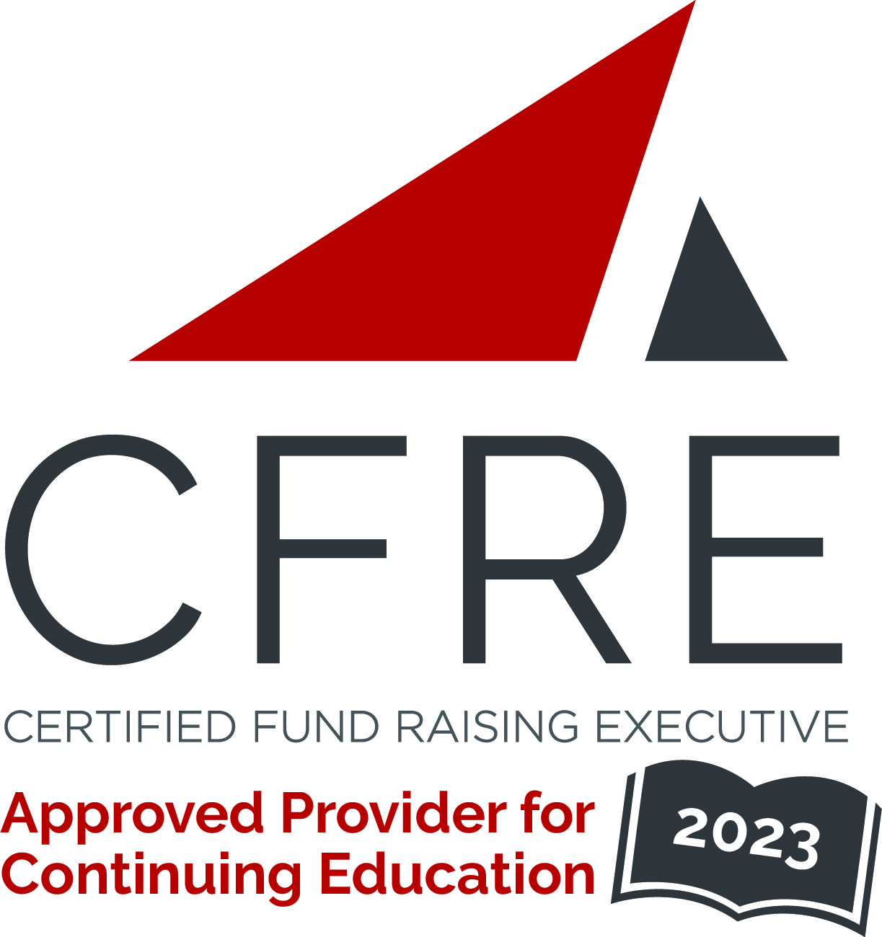  CFRE International has developed this form as a way for you to quickly track (and keep in your files!) the continuing education sessions you have attended. Simply check the boxes next to the sessions you attended. At the end of the conference, add up the total number of hours. Keep this sheet and you will be ready to complete your application form. All of the session slots listed are eligible for continuing education points on your CFRE application for initial certification and/or recertification. Sessions not listed here are not eligible for points. |  | CONTINUING EDUCATION POINTS TRACKER

Activity Organizer: - DonorPerfect
Title of Activity: - DonorPerfect Community Conference 2023
Names of Presenter(s): - Various
Dates and Location: - June 6-7, 2023 Online

Day 1

Date: Tuesday, June 6, 2023
Session 1: 10:30am – 11:20am (1pt)

- Refreshing Nonprofit Innovation: Overcoming Obstacles and Igniting Impact

Date: Tuesday, June 6, 2023
Session 2: 11:30am – 12:20pm (1pt)
- How to Refine Your Online Donor Journey: Turning Your Mission into a Movement

Date: Tuesday, June 6, 2023
Session 2: 11:30am – 12:20pm (1pt)
- Reinvigorate Your Fundraising Efforts with Constant Contact and DonorPerfect

Date: Tuesday, June 6, 2023
Session 3: 12:30pm – 1:20pm (1pt)
- How to Revamp Your Online Donation Form & Increase Its Value

Date: Tuesday, June 6, 2023
Session 3: 12:30pm – 1:20pm (1pt)
- How to Reposition Yourself as an Advisor to Major Donors

Date: Tuesday, June 6, 2023
Session 3: 12:30pm – 1:20pm (1pt) [Canada Only]
- How to Correctly Reassess Your Charitable Receipting Process: The Dos and Don’ts

Date: Tuesday, June 6, 2023
Session 4: 1:30pm – 2:20pm (1pt)
- Inspiring Donors to Reciprocate: The Case for Radical Connection

Date: Tuesday, June 6, 2023
Session 4: 1:30pm – 2:20pm (1pt)
- Restructuring Your Major Gift Pipeline: Cultivate the Right Donors with the Right Criteria

Date: Tuesday, June 6, 2023
Session 5: 2:30pm – 3:20pm (1pt)
- How to Review Your Engagement Strategy: Finding Donors on the Fringes

Date: Tuesday, June 6, 2023
Session 5: 2:30pm – 3:20pm (1pt)
- Reinvesting in Women: The Future of Nonprofit Leadership

Date: Tuesday, June 6, 2023
Session 6: 3:30pm – 4:20pm (1pt)
- Reigniting Innovation Within Your Organization

Day 2

Date: Wednesday, June 7, 2023
Session 1: 10:30am – 11:20am (1pt)
sio

- How to Rethink and Reimagine Nonprofit Culture

Date: Wednesday, June 7, 2023
Session 2: 11:30am – 12:20pm (1pt)
- Getting Dynamic: How to Recalibrate Your Strategic Plan for 2024

Date: Wednesday, June 7, 2023
Session 2: 11:30am – 12:20pm (1pt)
- Rebooting Your Digital Fundraising Strategy: 3 Proven Trustraising Steps to 5x Engaged Donors

Date: Wednesday, June 7, 2023
Session 3: 12:30pm – 1:20pm (1pt)
- How to Reflect on Past Performance to Meet Future Goals

Date: Wednesday, June 7, 2023
Session 3: 12:30pm – 1:20pm (1pt)
- Beyond the Thank You: How to Realign Your Stewardship Plan with Your Organization

Date: Wednesday, June 7, 2023
Session 3: 12:30pm – 1:20pm (1pt) [Canada Only]
- Best Practices for Receipting & Reconnecting with Donors

Date: Wednesday, June 7, 2023
Session 4: 1:30pm – 2:20pm (1pt)
- Renavigating the Road to Monthly Giving Success

Date: Wednesday, June 7, 2023
Session 4: 1:30pm – 2:20pm (1pt)
- The Power of Stewardship in Rejuvenating Your Existing Donors

Date: Wednesday, June 7, 2023
Session 5: 2:30pm – 3:20pm (1pt)
- How to Re-engineer Your Donation Process: Turning Small Donors into Monthly Givers

Date: Wednesday, June 7, 2023
Session 5: 2:30pm – 3:20pm (1pt)
- How to Remodel Your Prospect Marketing Strategy Using AI

Total number of points attained: __________

